**Transformer Resistance Calculations**

First of all, the skin effect should be calculated at the switching frequency of our design.

$$δ=\sqrt{\frac{2*ρ}{μ*w}}$$

$$=\sqrt{\frac{2*1.72*{10}^{-8}}{2*π*35000*1.256629*{10}^{-6}}}=0.353 mm$$

The diameter of the wire should be chosen regarding the skin effect on the current capability of the wire. When the AWG table is examined, AWG-21 is found suitable for the wire of the transformer which has a diameter of 0.723 mm.

Both the primary and the secondary windings are winded on the middle of the E- Core. From the datasheet of the chosen magnetic core, the following figure, which illustrates the dimensions of the core, is obtained.

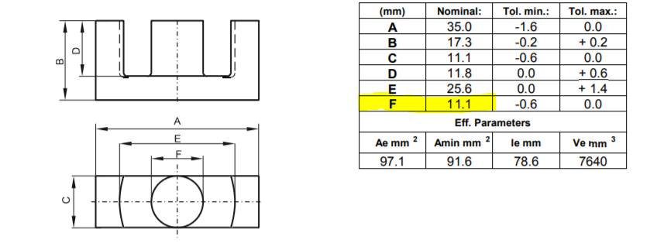

Figure x – The dimensions of the E – Core 0P43434EC

Considering that the primary winding is winded first on the middle part of the E – Core, the circumference of the part F must be calculated first.

The circumference is equal to : π * R , where R = 11.1 mm as highlighted in Figure X.

= 34.87 mm.

For the primary winding, Np = 15. Thus, the total wire length at the primary winding is equal to 15 * 34.87 = 0.523 m. At the AWG table, the resistance/length constant is given as 42 mΩ/m . Resistance of the wire in the primary winding is calculated as :

Rp = 0.523 * 42 ${10}^{-3}$* = 0.0219 Ω.

The secondary winding will be winded on the primary winding which increases the circumference of the surface. New circumference can be found as :

= π * R , where R = 11.1 + 0.723*2 = 12.54 mm

= 39.41 mm.

For the secondary winding, Ns = 20. Thus, the total wire length at the secondaru winding is equal to 20 * 39.41 = 0.788 m. At the AWG table, the resistance/length constant is given as 42 mΩ/m . Resistance of the wire in the secondary winding is calculated as :

Rp = 0.788 * 42 ${10}^{-3}$* = 0.033 Ω.